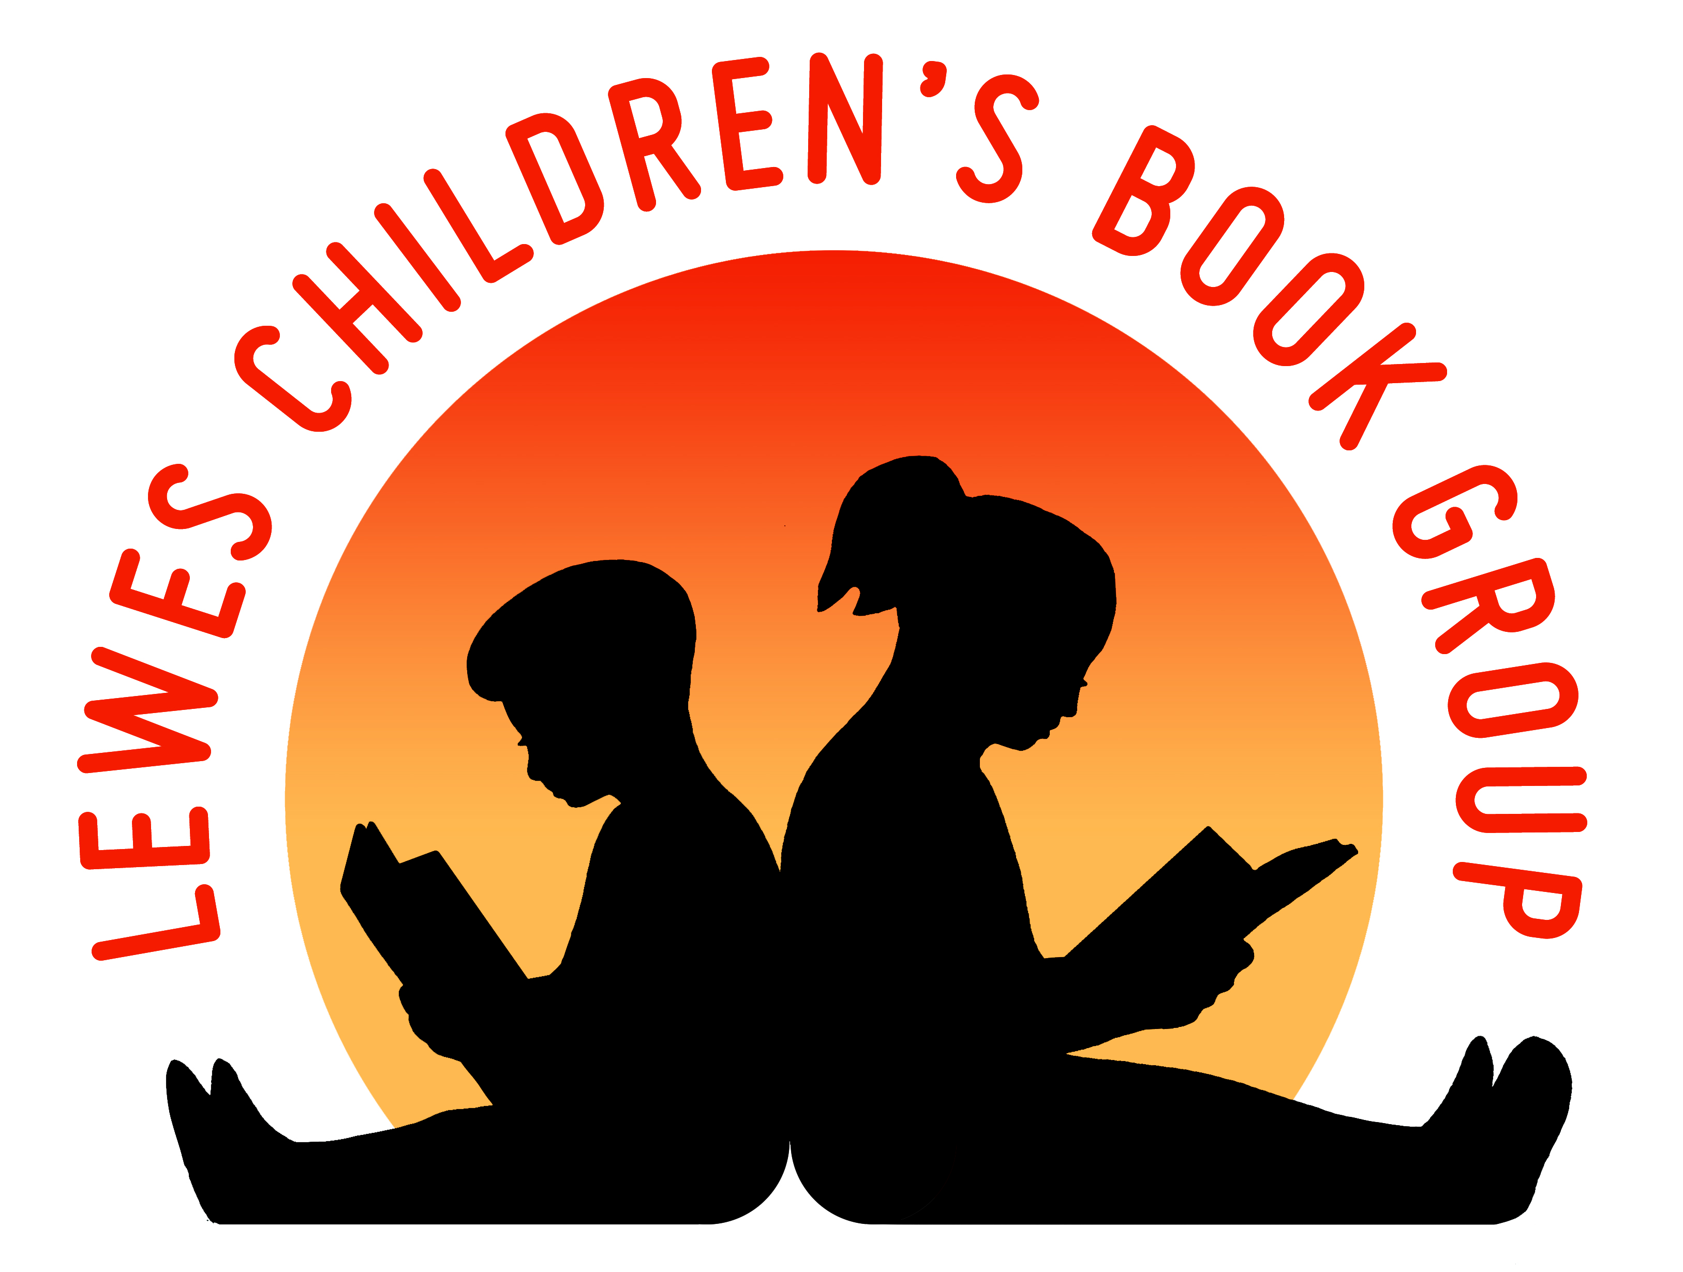
Lewes Children’s Book Group
Reg charity no: 268289

Individual Membership Application

Please complete this form in block capitals and email it to lewescbg@gmail.com

Name:………………………………………………………………………………..

Address:

………………………………………………………………………………………

………………………………………………………………………………………

………………………………………………………………………………………

Postcode:……………………………………………………………………………

Tel:..……………………………………………………………..………..………...

Email address: ………………………………………………………………………

Age of children: …………………………………………………………………….

By providing your email address you agree to be contacted occasionally by email about Lewes Children’s Book Group events. We will not pass your details onto any other individuals or organizations.

The cost of individual membership is £7.00. Please pay by bacs using these details.

Account Number: 00276951,
Sort Code: 30-95-01,
Reference: Subs 2020 LCBG

Signature: ……………………………………..….……… Date:…………………………...….

www.leweschildrensbookgroup.org.uk

