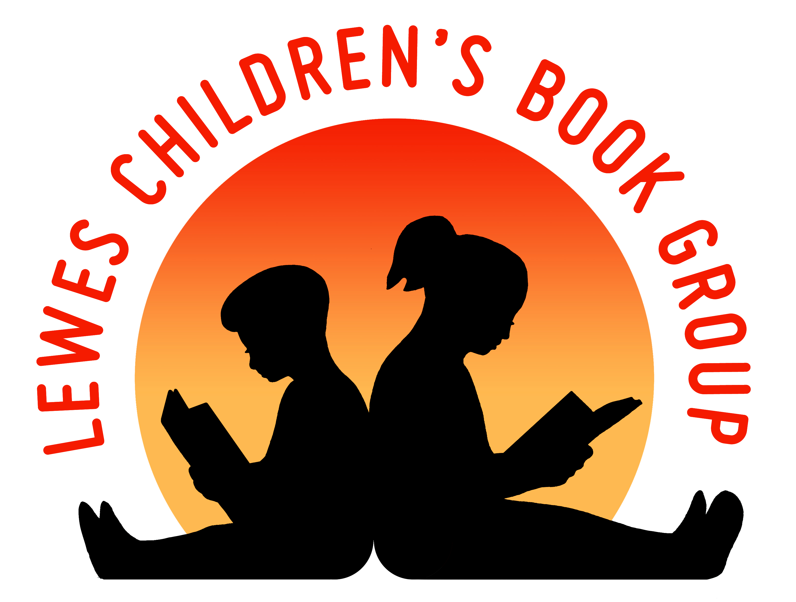
Lewes Children’s Book Group
Reg charity no: 268289

Membership Application

Please complete this form in block capitals and return it with a cheque or cash to:
Diana Rogers
48 South Way
Lewes, BN7 1LY
Tel: (01273) 474964

Name:………………………………………………………………………………..

Address:

………………………………………………………………………………………

………………………………………………………………………………………

………………………………………………………………………………………

Postcode:……………………………………………………………………………

Tel:..……………………………………………………………..………..………...

Email address: ………………………………………………………………………

Age of children: …………………………………………………………………….

By providing your email address you agree to be contacted occasionally by email about Lewes Children’s Book Group events. We will not pass your details onto any other individuals or organizations.

I enclose £7.00 to cover the annual subscription.
Cheques should be made payable to ‘Lewes Children’s Book Group’.

Signature: ……………………………………..….……… Date:…………………………...….

www.leweschildrensbookgroup.org.uk

